**Assignment : 9**

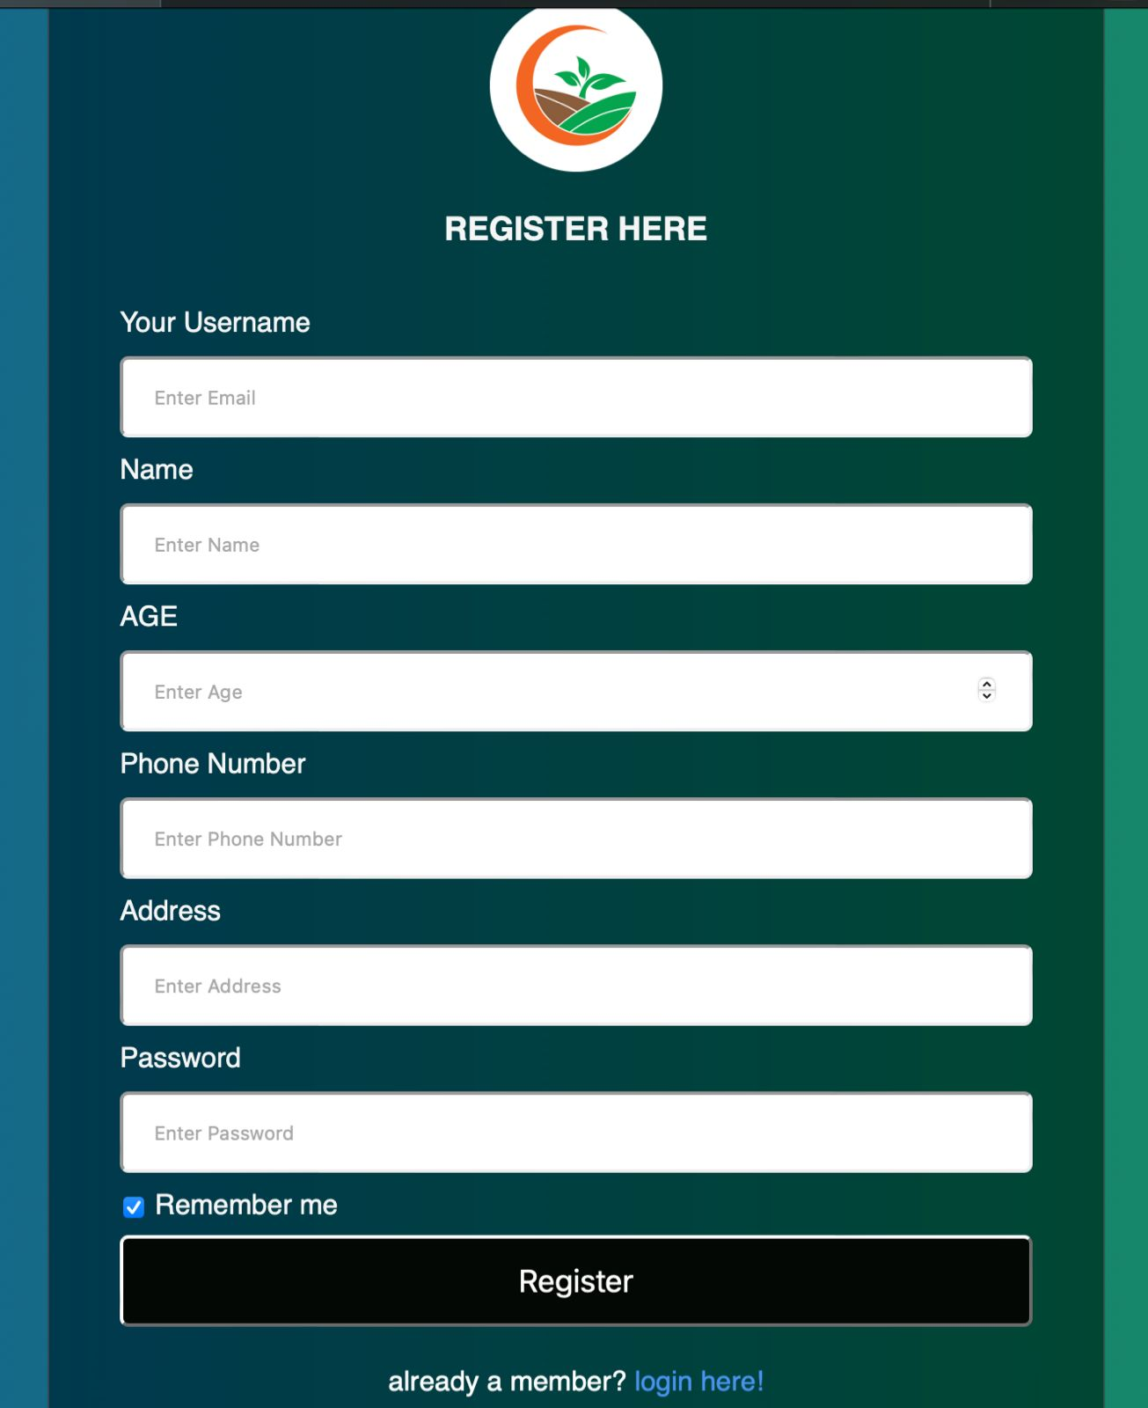

**Registration Form**

**Validate :**

**Your Username :**  Should not be empty.

**Name :** Should not be empty.

**Age :**  It may be Empty.

**Phone Number :** It should not be empty.

**Address :** It Should not be empty.

**Password :** It should not be empty.

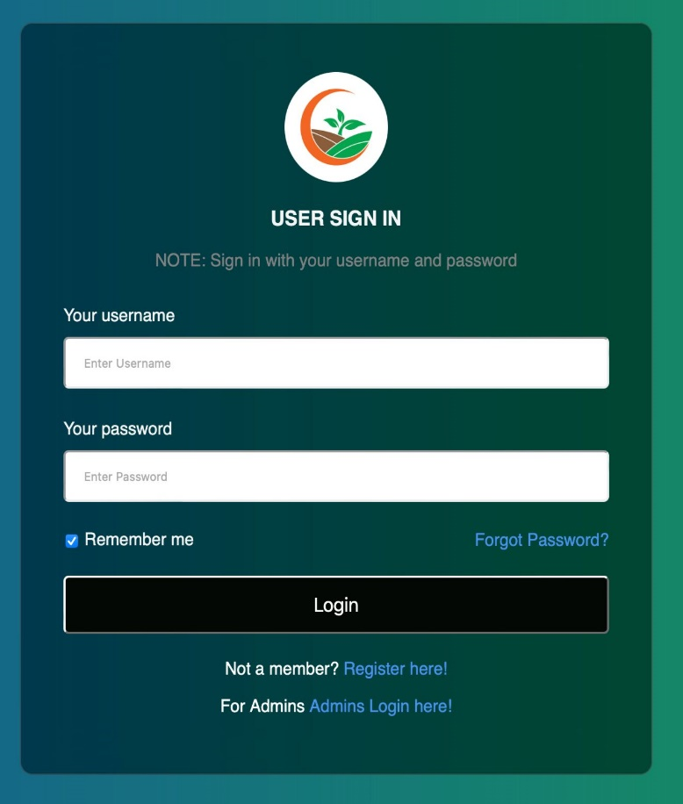

**Login Form**

**Your Username :** It should be non-empty.

**Password :**  It should be non-empty.

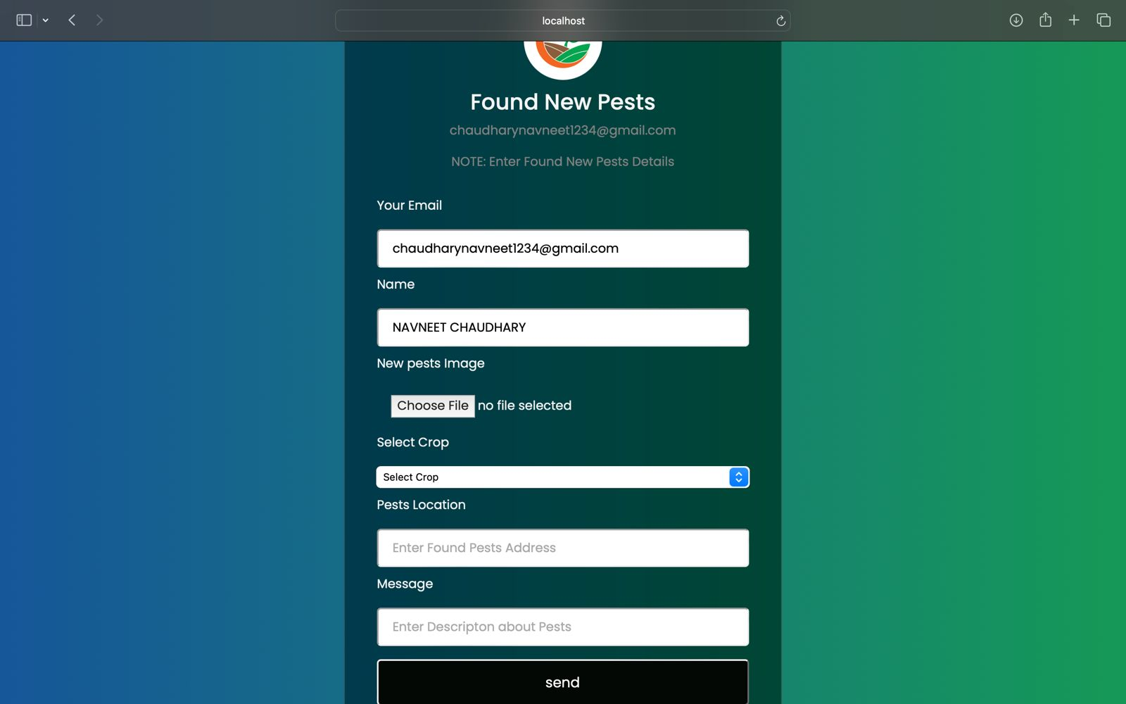

**Found New Pest Form**

**Your Email :**  It is already entered.

**Name :** It is already entered.

**New Pest Image :** It should be non-empty.

**Select Crop :** It should be non-empty.

**Pest Location :** It should be non-empty.

**Message :** It may be empty.

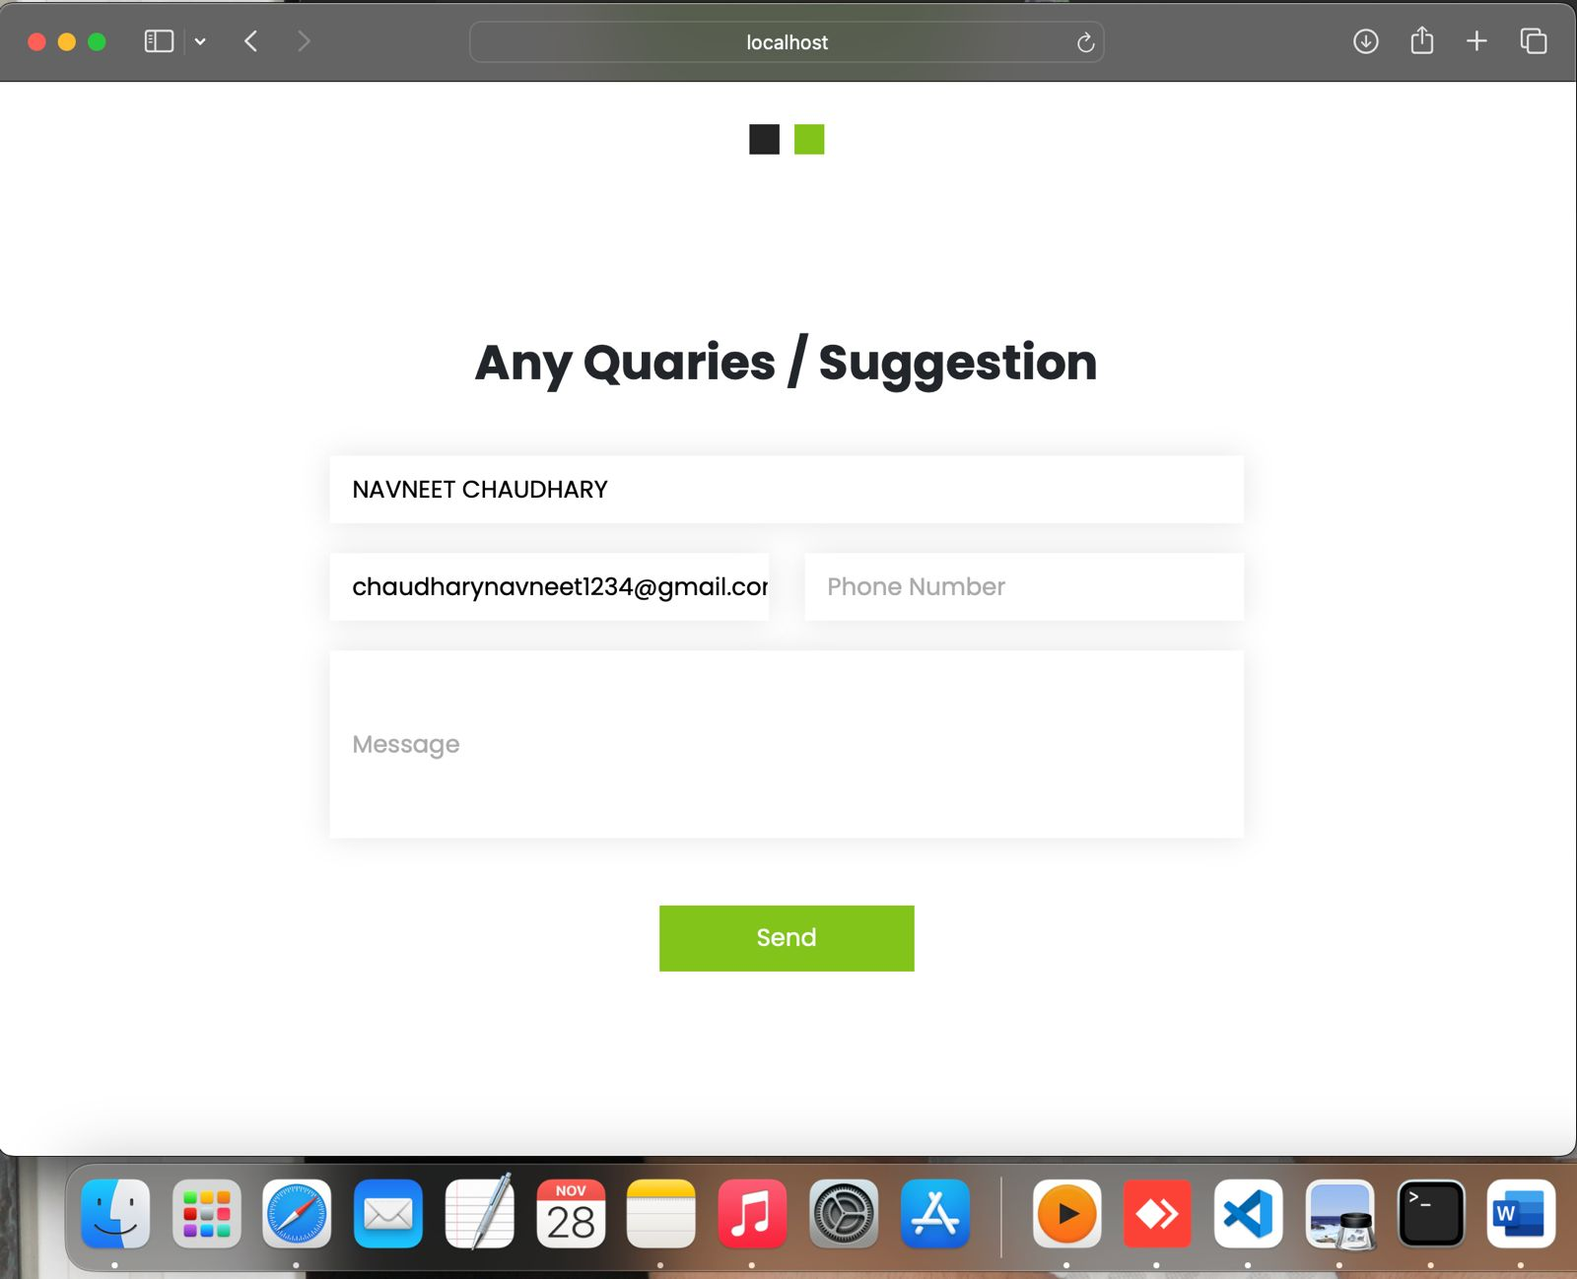

**Query Form**

**Your Name :** It is already entered.

**Email :** It is already entered.

**Phone Number :** It may be empty.

**Message :** It should not be empty.